High shear viscosity of yield stress materials is described by the three-component model

We test the validity of the Three Component (TC) model, describing the flow behavior of soft glassy materials. To highlight the importance of the viscous contribution from the continuous phase, we formulate a yield stress material with carbomer microgels and propylene glycol as a solvent. We demonstrate that the contribution of the solvent viscosity captured by the high shear viscosity term in the TC model is relevant and follows the solvent’s Arrhenius dependence as a function of temperature. This observation suggests a strong physical ground for this alternative model describing the steady flow of yield stress materials.

## Introduction

Carbomer based microgel systems are suspensions of high molecular weight poly-acrylic acid crosslinked to form microgel particles that are designed to swell in appropriate solvents. Carbomer microgels are widely used in pharmaceutical, cosmetics and consumer products industries as rheology modifier []. Perhaps the most iconic application of carbomer microgels is in the formulation of gel hand sanitizers: an alternative delivery of anti-bacterial liquid alcohol that created a unique product category just by means of a simple rheological modification of anti-bacterial alcohol. Besides the industrial relevance, carbomer microgels have also enabled fundamental research and have become a go-to model system for studying yield stress fluids. The availability of Carbopol yield stress model systems has enabled significant progress in the experimental investigation of the flow behavior of yield stress fluids and in the development of theoretical models connecting the microscopic properties of the system to the bulk rheological properties(Barry and Meyer 1979)(Kim et al. 2003)(Curran et al. 2002).

In this contribution we focus on the description of the steady shear flow properties of carbomer based yield stress fluids. The flow curve, viscosity or shear stress measured as function of the shear rate, is often described through the phenomenological Hershel-Bulkley (HB) model (Herschel and Bulkley, n.d.) shown in Eq 1. In this model, the steady shear stress $σ\left(\dot{γ}\right)$ where $\dot{γ}$ is the shear rate is expressed as the sum of a constant yield stress $σ_{y}$ and of a power law term $K{\dot{γ}}^{n}$. The second term describes the shear thinning properties of the material through the exponent $n$ and prefactor K. The shear thinning exponent *n* has been measured for a plethora of carbomer microgel systems and is typically found to vary between 0.3 and 0.7 depending on the type of carbomer, the carbomer concentration, the pH, and the preparation (Jaworski et al. 2021).

Equation 1

$$σ(\dot{γ})= σ_{y}+K{\dot{γ}}^{n}$$

The HB model provides an analytical description of the data and a convenient parametrization of the flow curve. However, there are two limitations of the HB description that will be highlighted in this work:

1. The intrinsic assumption of a vanishing viscosity term at infinitely high shear rates $\lim_{\dot{γ}→∞}{η}=0$, where $η$ is the viscosity of the fluid and $\dot{γ}$ the shear rate.
2. The variable high shear terminal scaling of the viscosity as function of shear rate

The first limitation is related to the description of the shear thinning properties of the system. Describing a shear-thinning fluid with a terminal power law exponent in the range 0 < n < 1, implicitly assumes that the viscosity will keep decreasing toward a zero-viscosity limit at infinite shear rate. For a carbomer microgel suspension, this leads to the paradox that the viscosity will eventually decrease below the viscosity of the continuous phase. In this work, we will show experimental evidence proving that the viscosity for a system with a Newtonian continuous phase does not vanish at high shear rates and instead trends to a constant, finite value.

To some readers (and possibly co-authors) the existence of a finite viscosity at high shear rates may appear glaringly obvious, but we believe it is important to explicitly present this evidence. To emphasize the contribution of the continuous phase on the high shear viscosity, we modify the widely utilized model system of Carbopol in water by replacing water with a thicker solvent, Propylene Glycol. This thicker solvent allows us to demonstrate that a non-zero high shear terminal viscosity is indeed required to properly describe the shear-dependent flow behavior of the system and that this viscosity is greater than and proportional to the viscosity of propylene glycol. This will also be clear by the scaling of the high shear terminal viscosity as a function of temperature that clearly follow the Arrhenius dependence of the pure solvent.

The second limitation is possibly less obvious but equally important. Since the HB description allows a variable terminal power law exponent at high shear, the many attempts(Ketz and Graessley 1988)(Cloitre et al. 2003)(Seth, Locatelli-Champagne, et al. 2011)(Story, Story, and Jaworski 2020)(Liu et al. 2018)(Lara-Peña et al. 2021) to build master curves by multiplicative rescaling of the stress and shear rate should not be expected to be successful. A universal master curve is only possible when using curves that share the same shear thinning exponent *n*. To exemplify this, we digitized data of Carbopol yield stress fluids formulated in different solvents: Glycerin, PEG, and mixtures of glycerin and PEG (Migliozzi et al. 2020). This set of data represents one of the few published examples of Carbopol systems in solvents significantly thicker than water. Exploring different solvent is of interest since some application like toothpaste formulation uses Carbopol microgel in glycerin or PEG and from a fundamental point of view, in designing a model system we want the ability to tune all relevant properties of the fluid. The HB description of every flow curve is good by any metric and yields the parameters summarized in table I. Rescaling of the curves onto a single master curve according to the HB natural scaling expressed in eq. 2, yields the result shown in figure 1 (a). It is clear within this set of data that when the *n* exponent varies significantly within a collection of flow curves, the rescaled master curve only collapses at low shear rate and maintains different terminal slopes at high shear.

Equation 2

$$\frac{σ}{σ_{y}}=1+{\left(\frac{\dot{γ}}{{(σ}_{y}/{K)}^{1/n}}\right)}^{n}$$

Table 1: HB and TC fit parameters for flow curves digitized from (Migliozzi et al. 2020)

|  |  |  |  |  |  |  |  |
| --- | --- | --- | --- | --- | --- | --- | --- |
| **Sample** | | **HB parameters** | | | **TC parameters** | | |
| **Solvent**  **(viscosity)** | **Carbopol concentration** | **K** | **n** | **ystress** | **TC\_eta\_bg** | **TC\_gammadot\_crit** | **TC\_ystress** |
| **Glycerin**  **(0.815 pa s)** | **1%** | 22.22 | 0.65 | 1.00 | 2.13 | 0.0009 | 0.56 |
| **1.5%** | 56.17 | 0.60 | 4.30 | 2.93 | 0.0033 | 3.06 |
| **2%** | 66.51 | 0.58 | 18.63 | 2.00 | 0.0566 | 16.47 |
| **3%** | 167.04 | 0.50 | 54.05 | 0.13 | 0.1087 | 54.51 |
| **5%** | 500.09 | 0.47 | 132.93 | 0.00 | 0.0972 | 145.37 |
| **8%** | 1106.24 | 0.46 | 222.47 | 0.00 | 0.0580 | 251.28 |
| **50:50**  **PEG400:**  **Glycerin**  **(0.353 Pa s)** | **1%** | 14.43 | 0.67 | 0.32 | 1.87 | 0.0001 | 0.08 |
| **1.5%** | 38.46 | 0.62 | 3.39 | 2.76 | 0.0039 | 2.28 |
| **2%** | 66.60 | 0.56 | 12.73 | 1.50 | 0.0258 | 11.03 |
| **3%** | 159.59 | 0.48 | 36.09 | 0.00 | 0.0712 | 39.48 |
| **5%** | 509.83 | 0.45 | 127.71 | 0.00 | 0.1117 | 149.67 |
| **8%** | 980.05 | 0.48 | 222.23 | 0.00 | 0.0615 | 236.34 |
| **PEG400**  **(0.093 Pa s)** | **1.5%** | 9.74 | 0.62 | 0.42 | 0.77 | 0.0008 | 0.24 |
| **2%** | 22.72 | 0.59 | 5.20 | 0.93 | 0.0375 | 4.48 |
| **3%** | 61.41 | 0.51 | 27.33 | 0.14 | 0.1962 | 27.18 |
| **5%** | 163.03 | 0.49 | 82.04 | 0.26 | 0.2800 | 83.66 |
| **8%** | 651.81 | 0.42 | 197.64 | 0.00 | 0.2426 | 252.55 |

To solve these two limitations, we tested the validity of the Three Component model, eq3, previously applied to concentrated emulsion systems (Caggioni *et al.*), that essentially deviates from the HB description in two fundamental aspects:

* Introduces an additional additive term, $η_{bg}\dot{γ}$, on the description of the stress $σ\left(\dot{γ}\right)$ that accounts for a non-zero terminal viscosity, $η_{bg}$. In the current formulations with Newtonian continuous phase we assume this term to be independent from the shear rate but in principle a dependence could be added $η_{bg}(\dot{γ})$.
* Fixes the shear thinning exponent of the power law term to 0.5 as predicted by different theoretical models (Seth, Mohan, et al. 2011).

Equation 3

$$σ(\dot{γ})= σ_{y}+σ_{y}{\left(\frac{\dot{γ}}{{\dot{γ}}_{c}}\right)}^{0.5}+η_{bg}\dot{γ}$$

Similarly to the HB model, the TC model has three parameters: the yield stress $σ_{y}$, the critical shear rate that is related to a microscopic stress relaxation time ${\dot{γ}}_{c}$ [], and the background viscosity $η_{bg}$ that is approached at high shear rates.

These two simple yet important differences allow us to solve the two limitations of the HB model described above:

1. The TC model removes the unphysical assumption of vanishing high shear viscosity and defines the viscosity at the high shear limit such that $\lim_{\dot{γ}→∞}{η}=η_{bg}$
2. Allows universal rescaling of flow curves via the natural renormalization suggested by the model that implies subtraction of the viscous background from the stress and normalization to the yield stress. On the shear rate axis a simple normalization with the critical shear rate parameter eq 4.

Equation 4

$$\frac{σ(\dot{γ)}-η_{bg}\dot{γ}}{σ_{y}}= 1+{\left(\frac{\dot{γ}}{{\dot{γ}}_{c}}\right)}^{0.5}$$

Applying this normalization, we expect all curves to collapse on a master curve with terminal exponent 0.5 as predicted by theoretical models[]. For the published set of flow curve data from (Migliozzi et al. 2020) we observe that this is indeed the case as for the experimental data we will show in the following.

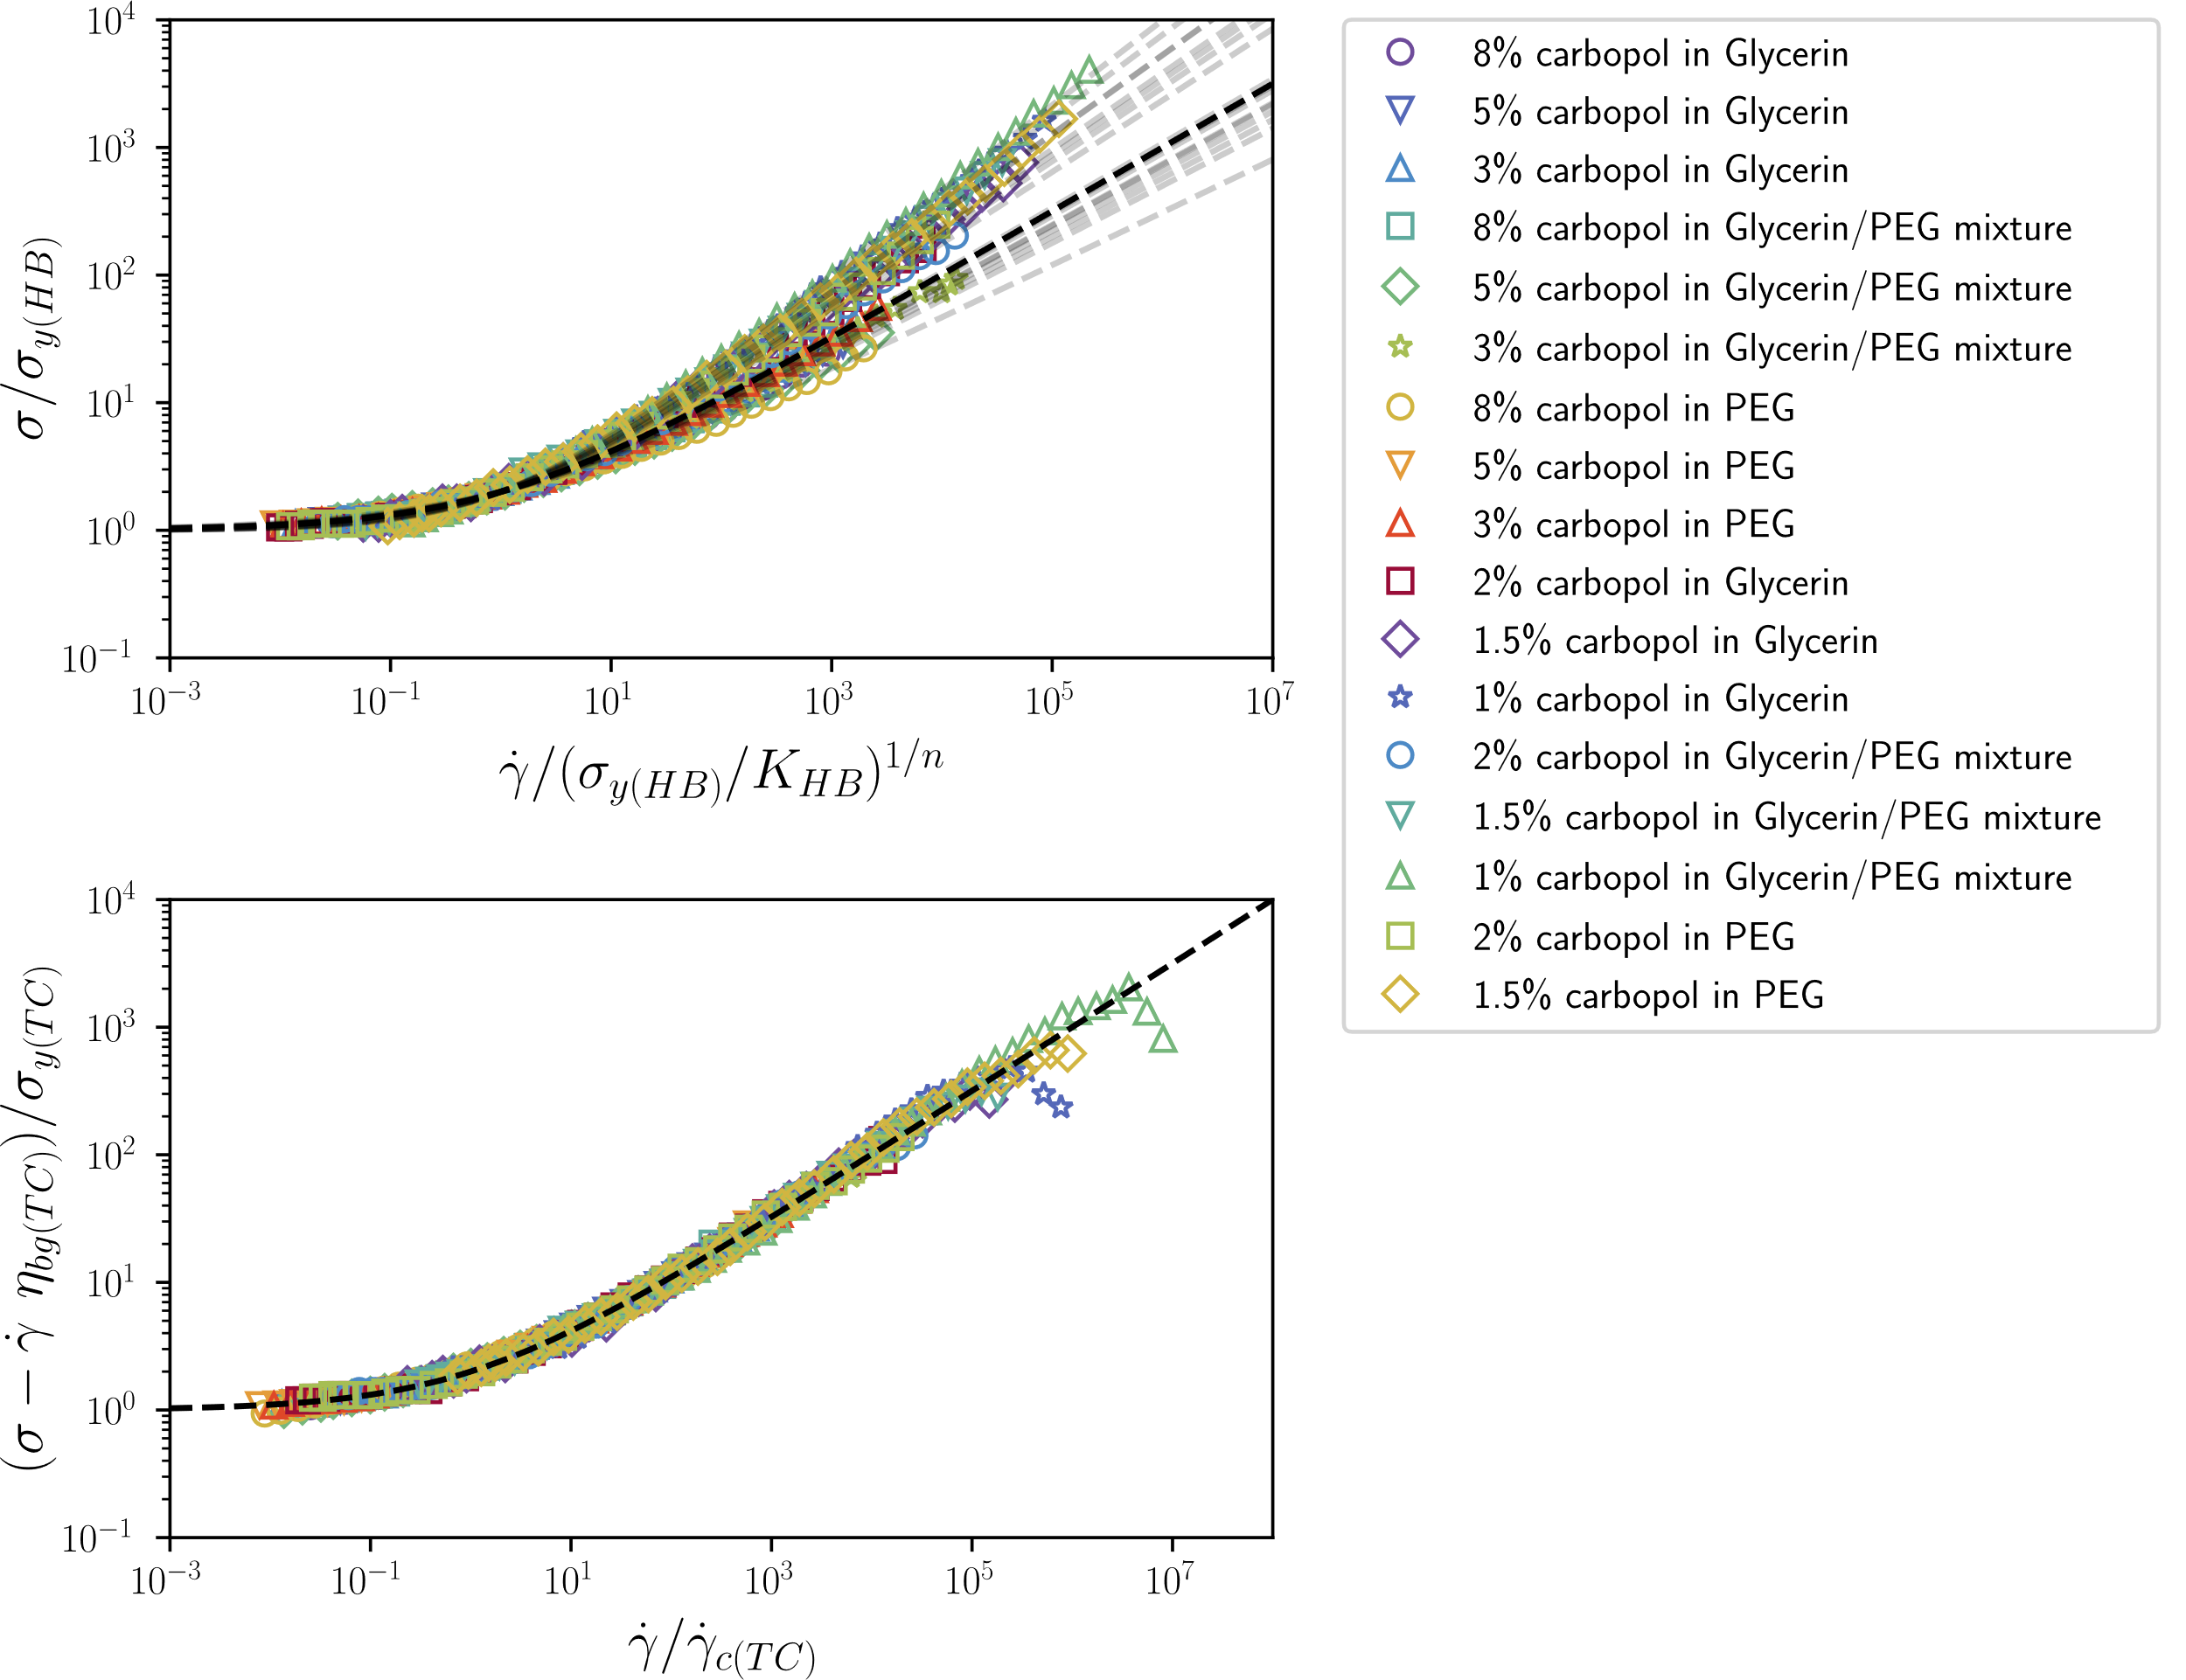

Figure 1 : Presentation of steady flow data digitized from (Migliozzi et al. 2020). The microgel is always the same, but the solvent properties and microgel concentrations vary. (a) : Natural rescaling of data suggested by the Heshell-Bulkley model following equation 2. The black dashed line is $1+{\dot{γ}}^{0.5}$ as predicted by theoretical models, and the grey dashed lines are $1+{\dot{γ}}^{n}$, using the n in table 1 for each sample. (b) : Natural rescaling suggested by the Three Component model as presented in equation 4. The black dashed line is $1+{\dot{γ}}^{0.5} as predicted by theoretical models$.

The remaining of this article will be structured this way:

* Material and methods: we describe the formulation and processing of the model system used for this investigation
* Result section : we describe the set of flow curves measured consisting of a
  + Concentration sweep
  + Temperature sweep with temperature dependent solvent viscosity
* Discussion
  + Comparison TC HB on one FC with residuals
  + Table TC – HB concentration sweep
  + Table TC- HB temperature sweep
  + Arrhenius dependence of eta-bg and (7x solvent viscosity?)
  + Mastercurve
* Conclusions

## Materials and methods

An initial concentrated solution of Carbopol 974p (Lubrizol) and propylene glycol (propane-1,2-diol, Sigma Aldrich) is prepared by shearing 3 wt.% of Carbopol powder in propylene glycol at 7000 rpm for five minutes in a high shear mixer (Silverson LS M-A). The dilutions are done while the stock solution is still highly turbid and liquid before the polymers start to swell in the solvent.The solutions are sonicated for six hours at 50°C and then equilibrated on a rotating wheel at 10 rpm for one week before any measurements.

All steps are necessary to obtain reproducible samples. In particular, a shorter time in the sonicator bath leads to the presence of aggregates in the samples that can easily be observed through an optical microscope.

All rheological measurements are done with a commercial stress-controlled rheometer (Anton Paar MCR 300) within a sandblasted cone and plate geometry. The temperature is fixed to a precision of 0.01 °C by a Peltier hood.

Elastic moduli are extracted from the plateau value of the storage modulus obtained by imposing oscillations in the linear range for decreasing frequencies.

## Flow curves are measured by decreasing progressively the applied shear rate and waiting for the establishment of a steady flow. Additionally, we check that applying a constant shear rate for a long time lead to the same steady flow values.Results

An example flow curve is presented in figure 2a for a sample of 1.9 wt.% of carbopol in propylene glycol. It presents a typical yield stress material behavior with a plateau value at small shear rates. This flow curve can be described both with the Hershell-Bulkley and by the Three-Component model. The fit quality, represented in figure 2b in terms of residuals between the fit and the data is similar for both models. The Akaike Information Criterion (cite doi : [10.1109/TAC.1974.1100705](https://doi.org/10.1109/TAC.1974.1100705" \t "_blank)) (AIC) quantifies the quality of a model adjusted to data by assessing the quality of fit with additional constrains on the number of fitting parameters. This criterion is widely used to avoid both over and under fitting. In this case, which is representative of every flow curve observed in this study, the AIC values are extremely small for both the TC and HB models, see figure 2. This ensures that the two models can be considered good.

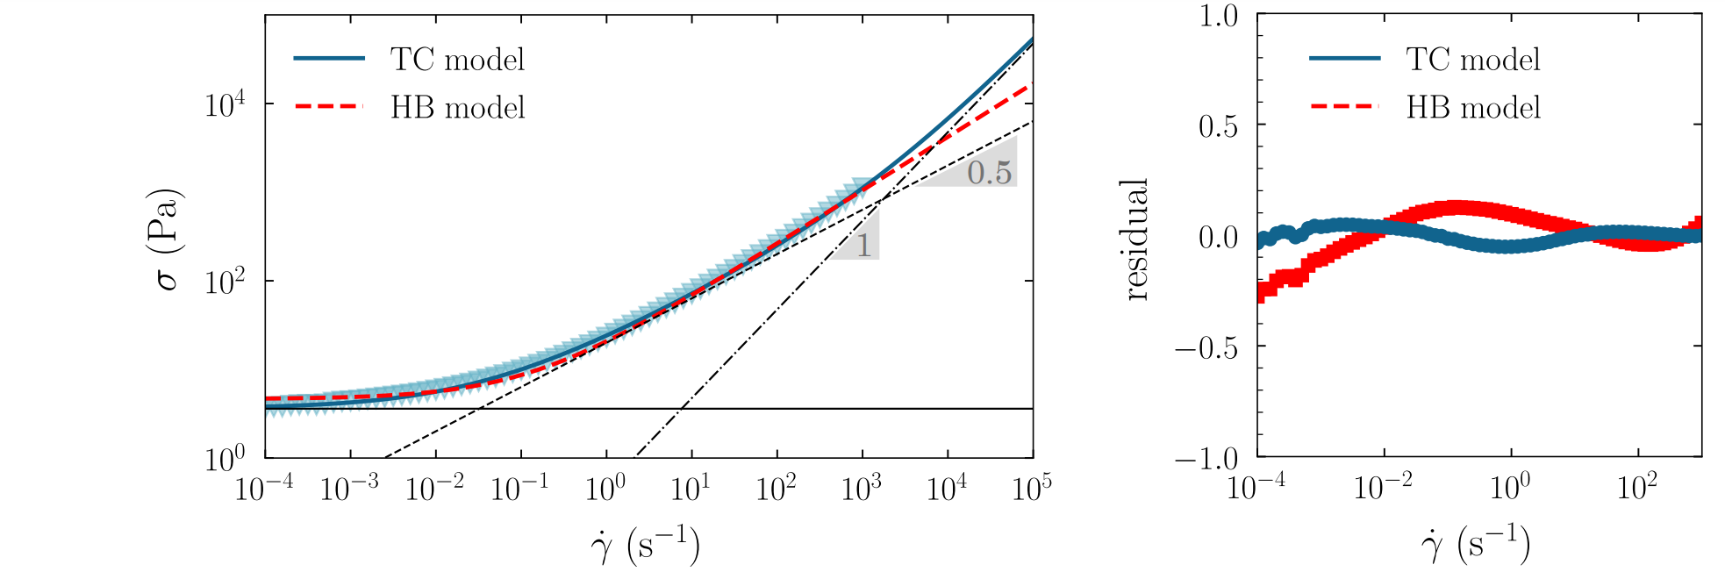

Figure 2 (A) Steady flow curve for a sample of 1.9 wt.% of carbopol in propylen glycol at 20°C. The blue line is a fit of the data with the three-component model. The parameters are σys = 3.6 ± 0.1 Pa, γ˙ c = 0.032 ± 0.001 s −1 , and η∞ = 0.476 ± 0.005 Pa·s with an AIC of −282. The dotted red line is a fit to the Hershell-Bulkley model with the parameters σys = 4.6 ± 0.2 Pa, n = 0.604 ± 0.004, and K = 16.1 ± 0.3 Pa·s 1/n with an AIC of −109. (B) Final residuals after adjustment of the three component model and the HershellBulkley model to the flow curve data.

Thus, the distinction between the Hershell-Bulkley model and the Three-Component model cannot be inferred from arguments on model selection criteria. In this study, we design an experiment which clearly highlights the additional physical meaning brought by the viscosity term in the TC model to the description of the flow.

We use a unique sample of Carbopol in propylene glycol and probe its flow properties at different temperatures. This sample is chosen just above the jamming transition of the system, see figure 3a and b.

Changing only the temperature but not the composition of the sample has the advantage of decoupling the contributions of the continuous phase, which packing is globally unaffected by temperature changes, from the continuous phase contributions. The chosen solvent, propylene glycol, presents a change of one order of magnitude in viscosity upon a temperature modification from 10 °C to 50 °C, see figure 3b. This decoupling is directly readable on the flow curves at different temperatures (fig 3a). The slope of the high shear regime are directly affected by the temperature changes while the yield stress values, read from the small shear behavior are smaller.

To highlight these observations, the flow curves are all fitted with the TC model. The parameters of the TC model are presented in figure

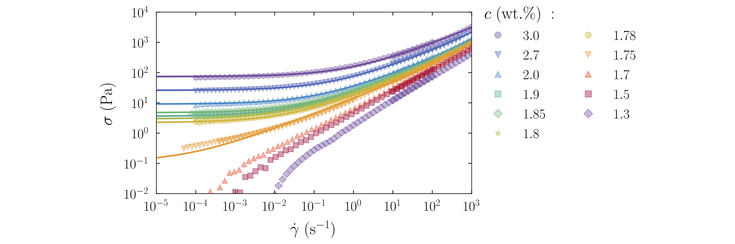

Figure 3: Concentration series of Carbopol 974p microgels in propylen glycol. All measurements in this figure are at 20◦C. (A) Dynamic yield stress $σ_{ys}$ σys and elastic modulus G as a function of the weight concentration c for samples of carbopol 971p in propylen glycol. The blue arrow highlights the 1.9% sample chosen just above the jamming transition. (B) Flow curves of the steady shear stress σ as a function of shear rate $\dot{γ}$ for the corresponding samples. The solid lines are adjustments with the three-component model. No yield stress is observed for concentrations below 1.75%.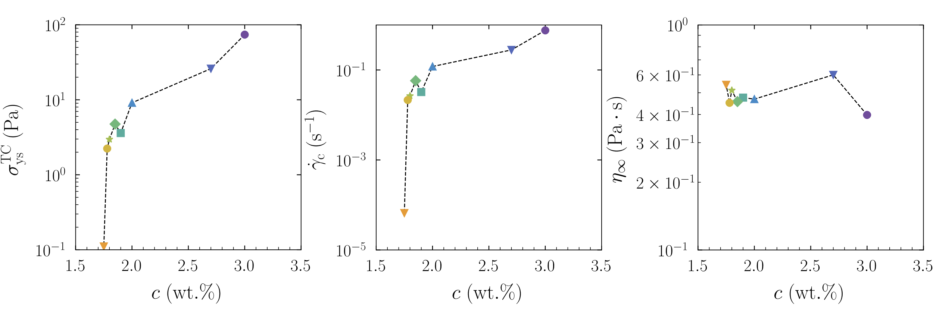

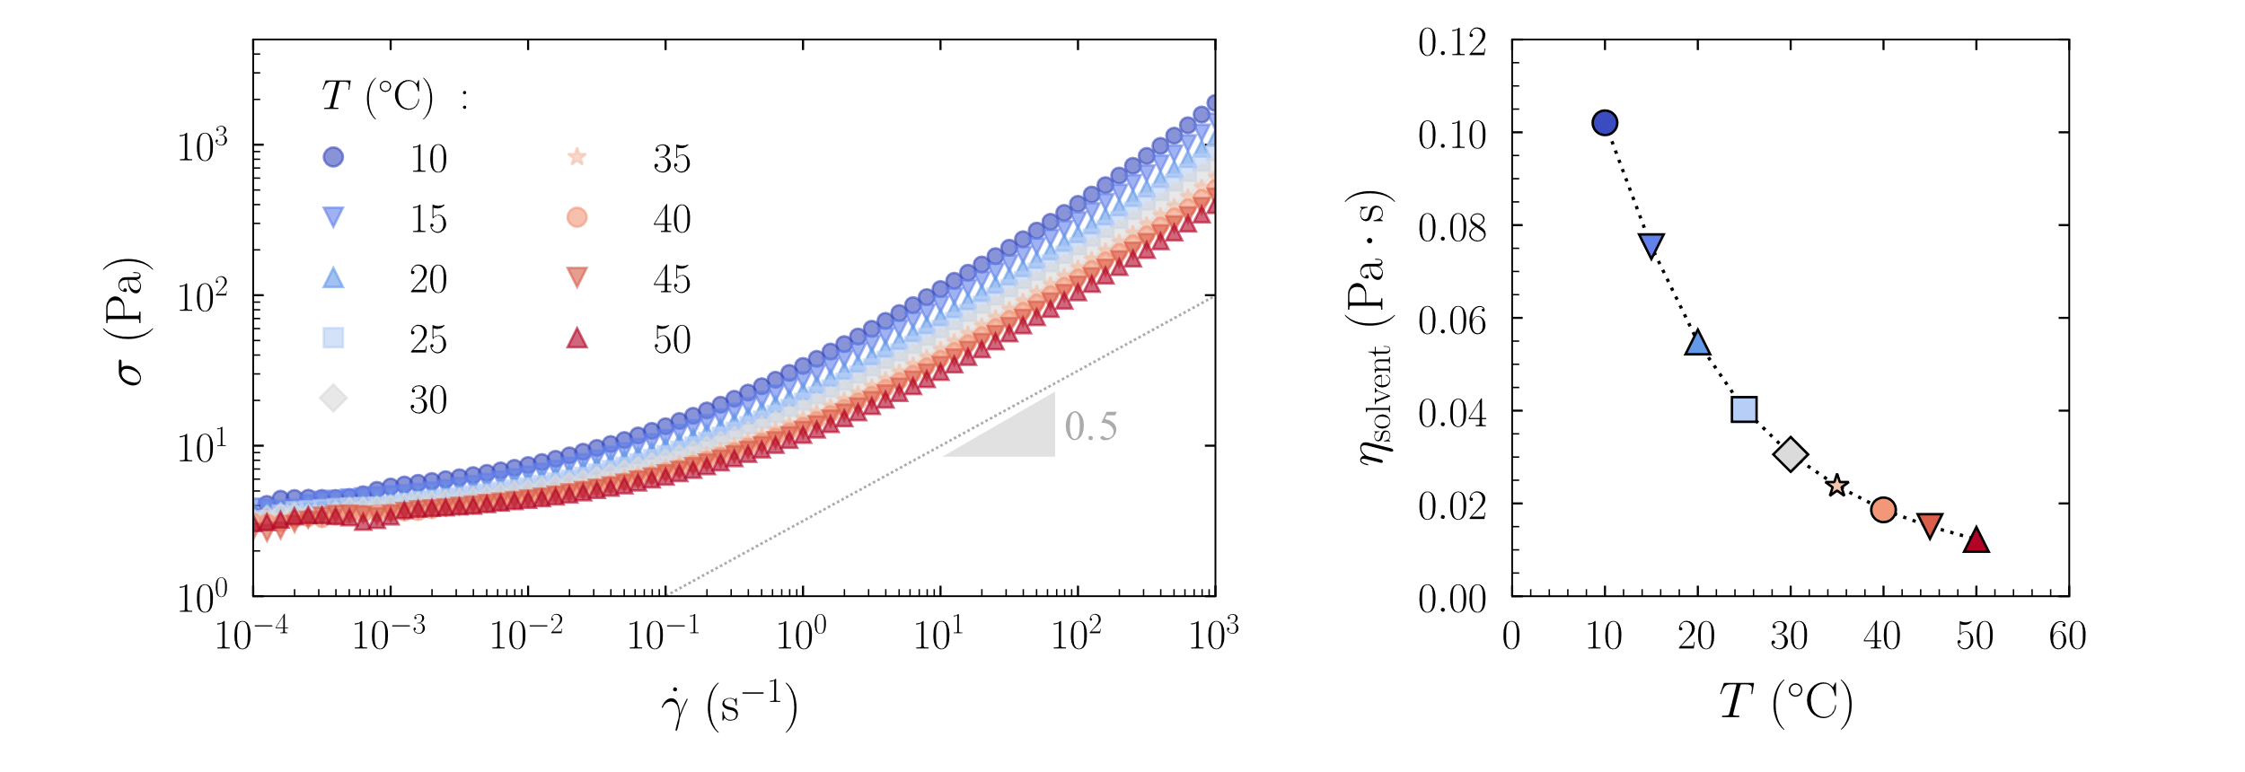

Figur3 Effect of temperature on the steady flow at high shear. (A) Flow curves for a unique sample with a weight concentration of Carbopol 1.9%. The steady stress σ is represented for each imposed shear rates $\dot{γ}$. Different symbols and colors correspond to different temperatures. (B) Viscosity of pure propylen glycol as a function of temperature.

## Discussion

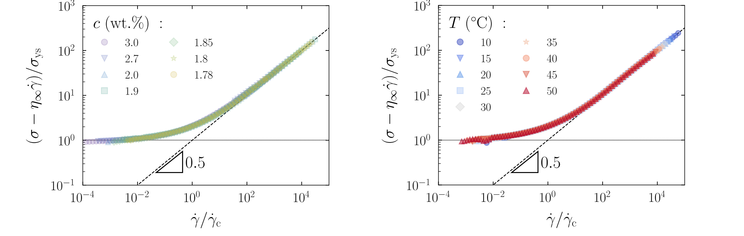

Figure 6 Master curves for the temperature and the concentration TODO Note for Marco here : I can also do a common master curve for temperature and concentration changes here, they are the same. Do you think it would be better ? I can add the mastercurve made with the automated ML tool from the recent article (Lennon, K. R., Mckinley, G. H. & Swan, J. W. A Data-Driven Method for Automated Data Superposition with Applications in Soft Matter Science. arXiv:2204.09521 (2022)) which should be almost identical

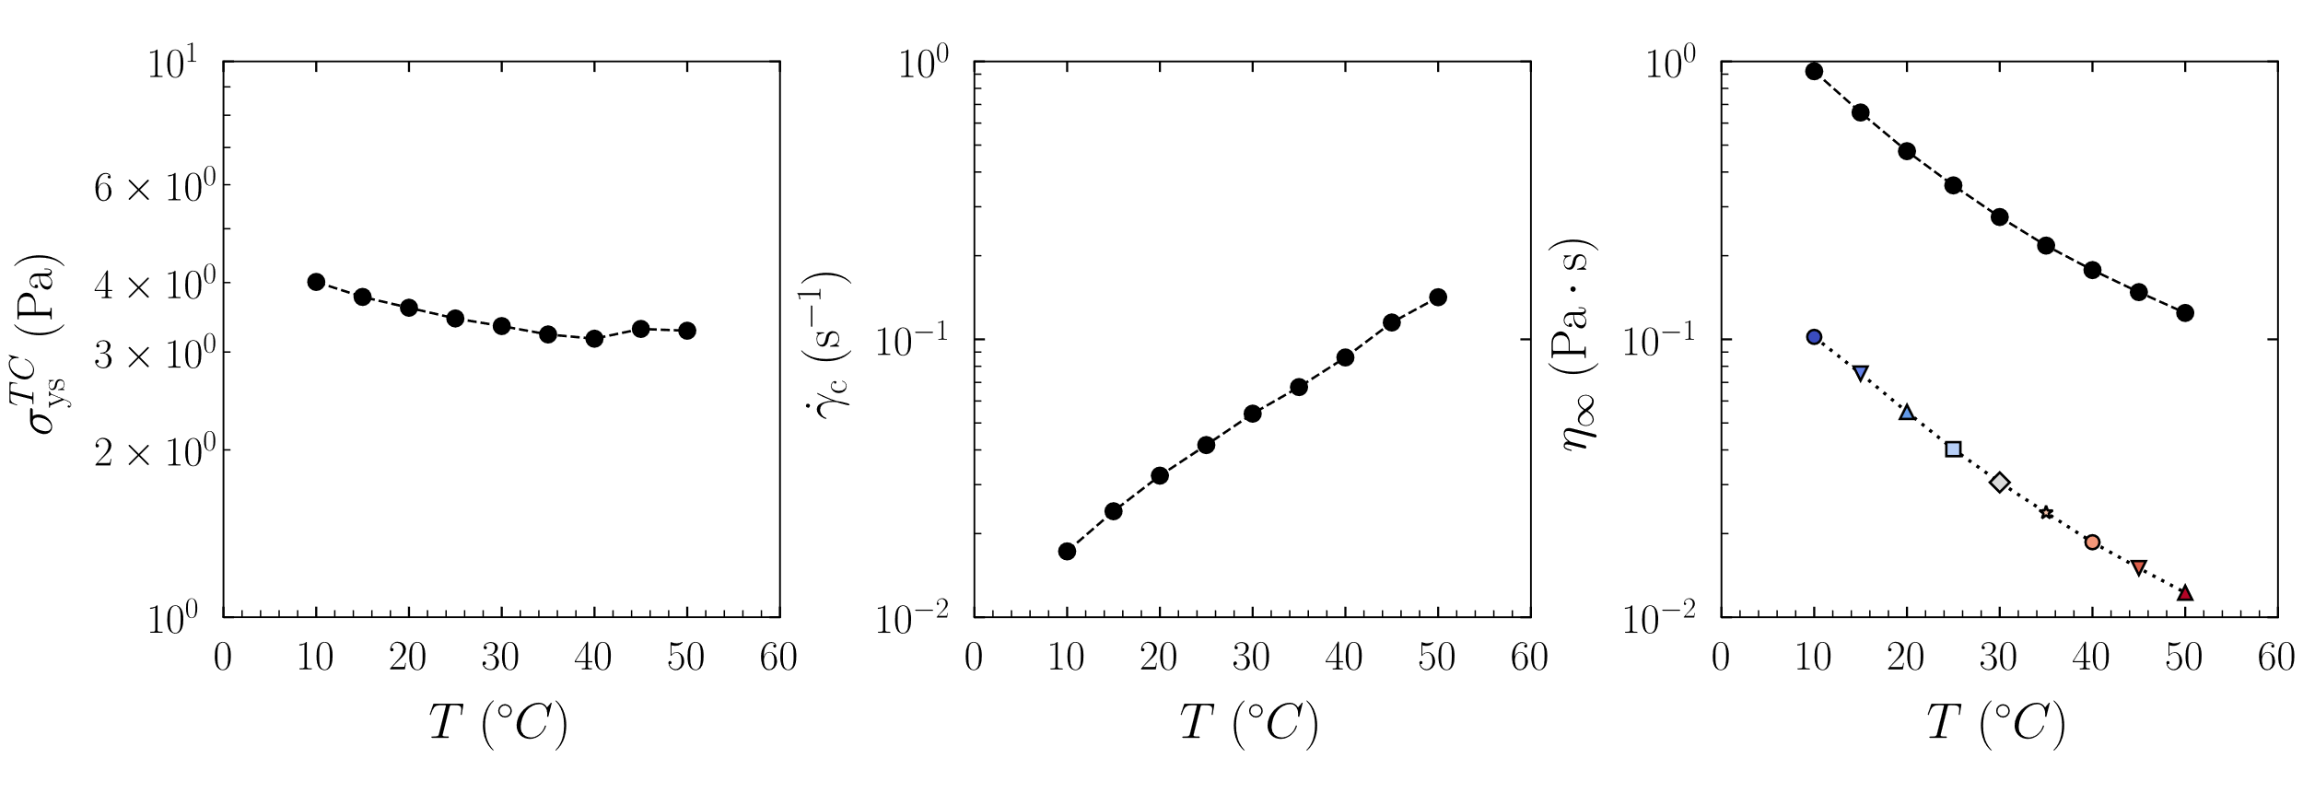

Figure 5 Temperature dependency for the different parameters of the three component model. Three jammed samples of weight concentrations 2.7, 1.9, and 1.8 % are presented. The three graphs correspond to (A) dynamic yield stress σys (B) critical shear rate γ˙ c, and (C) high shear viscosity η∞.

*Still in progress*

Finally, the analysis of the TC parameters trends as a function of temperature provides interesting insights. We first note that the yield stress figure 5(a) is virtually constant as we can expect since it is mostly a function of the volume fraction and elasticity of the microgel particles, quantities that are not expected to vary with temperature or solvent viscosity. The background viscosity varies significantly, figure 5(c), and almost precisely follows the Arrhenius scaling of the solvent viscosity, $η_{sol},$ only shifted by a multiplication factor, $p,$ that is volume fraction dependent:

$$η_{bg}∝{p\left(ϕ\right)η}_{sol}$$

The third parameter in the TC model, the critical shear rate, also varies as a function of temperature, in a way inversely proportional to $η_{bg}$, or equivalently to the $η_{sol}$:

$\dot{γ_{c}}∝1/η_{bg}$ or $\dot{γ_{c}}∝1/η_{sol}$

This observation provides an interesting insight when compared with theoretical and simulation results suggesting the critical shear rate to be of the form []:

$$\dot{γ_{c}}∝\frac{G_{0}}{η_{sol}}$$

Where $G_{0}$ s the low frequency linear elastic modulus. This proportionality is confirmed by our data. The dependence of the critical shear rate on elasticity

Discuss couplings?

* The coupling between the viscous and the plastic term – indicates that any variation of the background viscosity will correspond to a shift of the characteristic time controlling the plastic dissipation.
* The coupling between the elastic and plastic term, indicating that the elasticity controlling the yield stress also determine the plastic characteristic time.

## References

Barry, B. W., and M. C. Meyer. 1979. “The Rheological Properties of Carbopol Gels I. Continuous Shear and Creep Properties of Carbopol Gels.” *International Journal of Pharmaceutics* 2 (1): 1–25. https://doi.org/10.1016/0378-5173(79)90025-5.

Cloitre, Michel, Régis Borrega, Fabrice Monti, and Ludwik Leibler. 2003. “Hydrodynamics and Physics of Soft Objects/Hydrodynamique et Physique Des Objets Mous Structure and Flow of Polyelectrolyte Microgels: From Suspensions to Glasses Structure et Écoulement de Microgels Polyélectrolytes : De La Suspension Au Verre.” *C. R. Physique* 4: 221–30. https://doi.org/10.1016/S1631-0705(03)00046-X.

Curran, S. J., R. E. Hayes, A. Afacan, M. C. Williams, and P. A. Tanguy. 2002. “Properties of Carbopol Solutions as Models for Yield-Stress Fluids.” *Journal of Food Science* 67 (1): 176–80. https://doi.org/10.1111/J.1365-2621.2002.TB11379.X.

Herschel, Winslow H, and Ronald Bulkley. n.d. “Ronsistenzmessungen Yon ( Ummi-BenzollGsungen,’i.”

Jaworski, Zdzisław, Tadeusz Spychaj, Anna Story, and Grzegorz Story. 2021. “Carbomer Microgels as Model Yield-Stress Fluids.” *Reviews in Chemical Engineering*. De Gruyter Open Ltd. https://doi.org/10.1515/revce-2020-0016.

Ketz, R J, and W W Graessley. 1988. “Rheology of Concentrated Microgel Solutions.” *Rheologica Acta Rheol Acta* 27: 531–39.

Kim, Jong Yun, Jun Yeob Song, Eun Joo Lee, and Seung Kyu Park. 2003. “Rheological Properties and Microstructures of Carbopol Gel Network System.” *Colloid and Polymer Science* 281 (7): 614–23. https://doi.org/10.1007/S00396-002-0808-7/FIGURES/8.

Lara-Peña, M. A., A. Licea-Claverie, I. Zapata-González, and M. Laurati. 2021. “Colloidal and Polymeric Contributions to the Yielding of Dense Microgel Suspensions.” *Journal of Colloid and Interface Science* 587 (April): 437–45. https://doi.org/10.1016/J.JCIS.2020.11.101.

Liu, Tianfei, Fardin Khabaz, Roger T. Bonnecaze, and Michel Cloitre. 2018. “On the Universality of the Flow Properties of Soft-Particle Glasses.” *Soft Matter* 14 (34): 7064–74. https://doi.org/10.1039/C8SM01153B.

Migliozzi, Simona, Giovanni Meridiano, Panagiota Angeli, and Luca Mazzei. 2020. “Investigation of the Swollen State of Carbopol Molecules in Non-Aqueous Solvents through Rheological Characterization.” *Soft Matter* 16 (42): 9799–9815. https://doi.org/10.1039/D0SM01196G.

Seth, Jyoti R., Clémentine Locatelli-Champagne, Fabrice Monti, Roger T. Bonnecaze, and Michel Cloitre. 2011. “How Do Soft Particle Glasses Yield and Flow near Solid Surfaces?” *Soft Matter* 8 (1): 140–48. https://doi.org/10.1039/C1SM06074K.

Seth, Jyoti R, Lavanya Mohan, Clémentine Locatelli-Champagne, Michel Cloitre, and Roger T Bonnecaze. 2011. “A Micromechanical Model to Predict the Flow of Soft Particle Glasses.” *Nature Materials* 10 (11): 838–43.

Story, Anna, Grzegorz Story, and Zdzisław Jaworski. 2020. “Effect of Carbomer Microgel PH and Concentration on the Herschel-Bulkley Parameters.” *Chemical and Process Engineering*, no. 3: 173–82. https://doi.org/10.24425/cpe.2020.132540.